**Final Report**

**Software Defined Radio**

**Project Manager: James Bell**

**Samuel Hussey, Zachary Schneiderman**

**Texas State University**

**Ingram School of Engineering**

**SPONSOR Texas State University**

**601 University Drive**

**San Marcos, Texas 78666**

**5/1/2019**



# Overview

## Executive Summary

Texas State University sponsored the build of a HF software defined radio that was capable of operating on the 80m and 20m amateur radio bands. The team selected to complete this project consisted of James Bell, Zachary Schneiderman, and Samuel Hussey, three electrical engineering majors with two concentrations in computer engineering and one in micro and nano devices respectively. While the finished device itself functions as a transceiver on HF bands, the overarching goal of the project was to document the build with detailed schematics and clearly commented code so that it may be reproduced by students and amateur radio enthusiasts. To date, schematics, code, and receiving portion of the radio are finished and will be available to any who wish to learn about or practice amateur radio. Shortcomings currently include difficulties with transmission, though all components and code have been implemented. Specs that have been met include: reception and demodulation of single sideband modulated signals on the 80m and 20m bands, real time operation, and a user interface with volume control, frequency tuning and display, and license level selection.

In general, HF software defined transceivers cost >$300 and are a “black box” in terms of administrative access. The value in our project is that our design allows the user to build their own software defined radio for under $300 while at the same time learning and applying skills gained from the classroom, a priceless attribute that commercial products do not usually provide.

## Abstract

For a long time, amateur radio enthusiast, have dreamed of having radio signals processed by microprocessors, rather than bulky and fragile tuned components. With advancements in technology, we have finally reached a point where this is possible, but it is still expensive for most new comer to the hobby. Software Defined Radios use microprocessors and software to process signals and replace the traditional need of discrete tuned components to receive and transmit radio frequency signals. This is especially useful because one microprocessor can cover a wide range of frequency bands and can easily be modified in code to extend its functionality. Current software defined radios that operate in the VHF and UHF bands can be had for roughly $25. However, other software defined radios that operate on more desired HF bands can run from $300 at the low end to thousands of dollars. Our team wanted to create a radio that can operate on the two most common HF bands and can be built for under $300.

Contents

1 Overview 2

1.1 Executive Summary 2

1.2 Abstract 2

2 List of Figures 4

3 List of Tables 4

4 Problem Description 4

5 Progress Towards A Solution 6

5.1 Design Decisions 6

5.2 Design Approach 7

5.3 Project Approach 8

5.4 Engineering Standards 9

5.5 Progress Towards Goals 9

5.6 Verification 10

5.7 Characterization Results 10

5.8 Deficiencies 11

5.9 Iterations and Redefinitions 11

6 Constraints 11

6.1 Budgetary 11

6.2 Design Feasibility 12

6.3 Manufacturability 13

6.4 Maintainability 13

6.5 Environmental 13

6.6 Health and Safety 13

6.7 Social 13

7 Budgets 14

8 Work Schedule 16

9 Personnel Interactions 17

9.1 Teamwork 17

9.2 Mentorship 18

10 Ethics 18

11 Summary & Conclusions 18

12 Discussion 19

12.1 Academic Preparation 19

12.2 Lessons Learned 19

12.3 Soft Skills 19

12.4 Schedule Deviations 19

12.5 Staffing 20

12.6 Final Observations 20

13 Acknowledgments 20

14 References 21

# List of Figures

Page 4 – Figure 1: Top Level Diagram With Completed Blocks

Page 5 – Figure 2: Original Top Level Diagram

Page 6 – Figure 3: Current System Diagram

Page 7 – Figure 4: 80m Band Pass Filter

# List of Tables

Page 9 – Engineering Standards

Page 11 – Deficiencies

Page 14 – Budgets

Page 16 – Work Schedule

Page 17 – Teamwork

# Problem Description

Most software defined radio transceivers on the market are $300 or more. Our project is to create a cheaper alternative that facilitates understanding and learning by allowing the user to construct it themselves.

Our project deliverables are:

* Have an on off power switch with LED indicator
* Receiving single sideband on the 20m and 80m North American amateur radio bands
* Convert received single sideband signals to audio signals
* Take in audio signals and convert them to single sideband
* Taking said single sideband audio signal and transmitting it on the 20m and 80m North American amateur radio bands
* Show the currently tuned frequency, sideband, selected license level, and band of operation on a screen
* Run on standard US power (120V at 60Hz)
* Total unit cost to be under $300
* Volume control for speaker

This is the latest basic design we came up with after many hours of research and some trial and error:

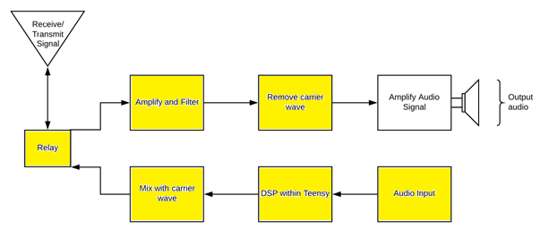

Figure 1: Top Level Diagram, Yellow Is what we have done ourselves

# Progress Towards A Solution

## Design Decisions

Here was the first ever top-level design: 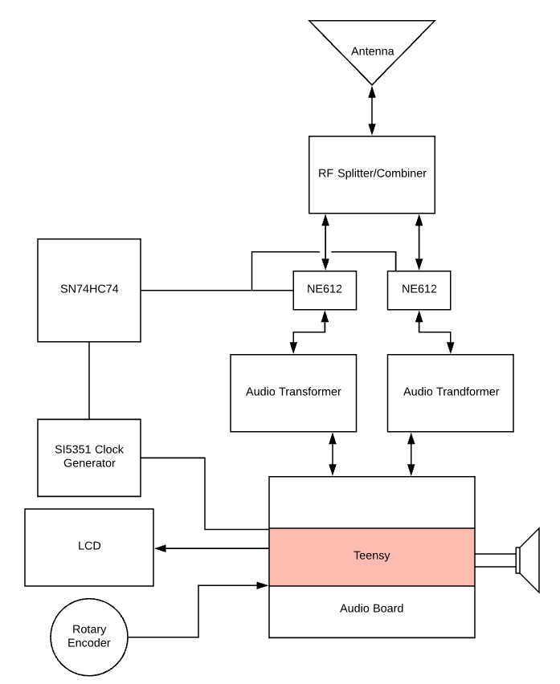

Figure 2: First ever top level design for system.

A close up of a logo

Description generated with very high confidence

Figure 3: Latest Overall design of system. No color

As one can tell, figure 2 and figure 3 are very different in both clarity and design. Some of the key changes I will list below and why they were done:

* The Teensy no longer sees the received signals directly. This was done to isolate the very sensitive Teensy from possible voltage spikes received in the system, reducing the chances the Teensy will be damaged or destroyed.
* The Audio isolation transformers were removed, as they seemed to only degrade and distort the signal sent to them.
* A relay was introduced to separate transmit and receive to reduce the chances of feedback in the system. If feedback from transmit was taken in to the RF amplifier and amplified it is possible the amplifier would have a catastrophic failure.
* The SN74HC74 D-flip flops were removed as we discovered the clock generator could perform the same function. This makes the device simpler in hardware and cheaper as those parts are no longer needed.
* The position of the RF splitter and combiner had to be broken in to 2 places. One Combiner after the “Mix with carrier wave” block and one splitter at the “Remove Carrier wave” block in figure 3. As this was useful for splitting and combining the signals only at the needed locations reducing cross talk in the system by reducing the number of RF wires in the system.

## Design Approach

Our initial design is based on Charlie Morris’s software defined radio project posted online. First, we wanted to simulate the design as best as possible. Our most accessible tool for simulating the analog components was and is the free circuit modeling software LTspice. Here is the 80m bandpass filter designed in LTSpice:

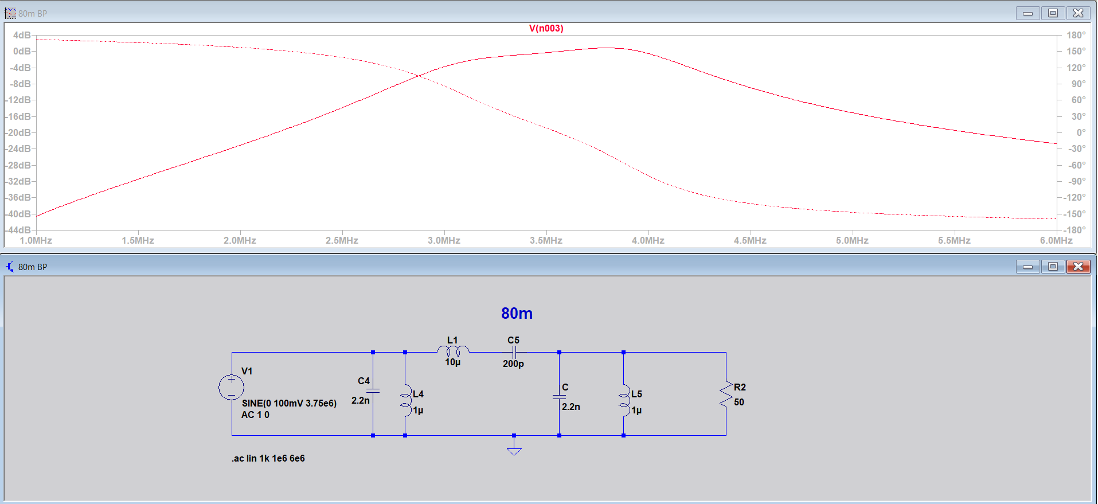

After modeling the analog components we could, we tested everything we could including the off the shelf components with the tools on the work benches in Ingram 2107. These tools are Keysight 334460A digital multimeter, InfiniiVision MSOX4054A mixed signal oscilloscope, 33600A series waveform generator, and the E36311A power supply.

## Project Approach

The project was organized and subdivided primarily on the Weekly Project Schedule. This

was updated every week at the time of writing out the weekly report. In this schedule each

member of the team was assigned a task, given a start date, due date, the number of days between the two dates, and the status of the project. This allowed us to keep track of who was doing what, when it was due, if it had been completed, and discus if the length of time given was adequate for the assigned task.

The first series of tasks included research into radios, meaning how they were often constructed, operated and used. In other words, establishing for us the fundamentals of radio development and operation to set our goals and deliverables against.

For the second step we looked in to a pre-existing Software defined radio project posted online by Charlie Morris. This individual’s design gave us a good starting place to work from.

From there we began simulating and modifying analog components for the North American radio frequency ranges, working on replacements, such as an off the shelf audio amplifier instead of his home made one for simplicity, and establishing software-controlled relays instead of his manual ones.

Step 4 was to start building the analog components and ordering the off the shelf components, this was done so that the analog components would be done at the same time the off the shelf components came in.

Step 5 was testing all the components individually and slowly integrating them as a system. Once a component was tested to our satisfaction, we integrated it with another component creating a hierarchy of sub-systems, each being tested as we went.

Step 6 included correcting found deficiencies from step 5 and creating the code for the receiving side of the radio as it is arguably the most important half of a radio.

Step 7 saw the beginning of reception tests and generating of test signals such as single sideband modulated music signals to be sent in to the radio and demodulated.

Step 8 is the transmit side of the radio, this is where we add the microphone, necessary Digital signal processing code, and begin transmitting testing of the radio. After correcting system deficiencies, the system will be complete.

## Engineering Standards

|  |  |  |  |
| --- | --- | --- | --- |
| **Standard** | **Title** | **Application** | **Relevance** |
| I2C | Inter-Integrated Circuit | Used between the Teensy, Clock generator, and LCD screen | Inter-circuit communications |
| FCC, Radio Frequency Devices | 15.5 General conditions of operation | This is the category of FCC regulation our radio falls under and the guidelines it must follow. | Radio transmit legality |
| International Telecommunication Union - J3E | single sideband suppressed-carrier | Limit of 3000Hz bandwidth for transmit | Standardization of transmit side of radio. |

## Progress Towards Goals

To date, we have completed all but one of our proposed deliverables. The transceiver currently: has a power board supplying all components with their recommended power, has gain of 18 and 12 on the 80m and 20m bands respectively, has an on/off switch with an indicating LED, can receive and demodulate SSB signals on the 80m and 20m bands and those bands only, operates in real time (defined as under 100ms), has an implemented rotary encoder and corresponding display as well as volume control on the audio amplifier. Currently, the transmit portion is not functional. Though all of the analog components are in place, implementing the microphone and configuring the code in order to process the signal has proved time consuming and challenging. In an effort to have a working demo for senior design day the decision was made to focus on other portions of the project.

## Verification

The majority of the testing was done with the available lab equipment, which proved more than adequate for the technical specifications we were looking to verify. The oscilloscopes and digital multimeters were used to probe various points of the transceiver in order to follow the signal through the analog components and verify its form and magnitude with expected values, as well as produce bode plots that confirmed the transceiver’s operable regions. The one technical test that did not utilize the lab equipment was the volume control. In order to confirm a variable volume within an acceptable range, a decibel meter application was used to measure the ambient noise levels in a room before the radio was turned on. Then, the volume was slowly turned up until it reached maximum volume at which point the decibel meter was used to again measure the noise levels near the speaker.

## Characterization Results

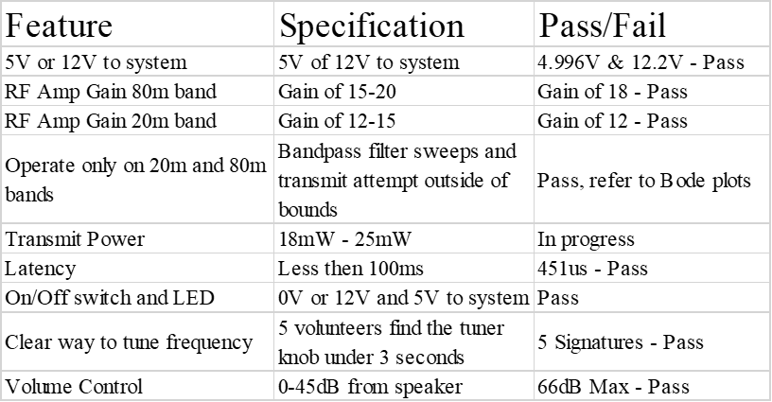

## Deficiencies

|  |  |  |
| --- | --- | --- |
| **Deficiency** | **Effects on System** | **Recommended Solution** |
| Transmit portion of radio not functioning | The software defined transceiver is currently operating as a receiver only | It is believed that the problem stems from two places, the mixing circuit and the implementation of the microphone. These issues have the potential to be rectified quickly but the research required to do so may be time consuming and require separate testing so that no key components surrounding them are damaged. The coupling capacitors and clock signal on the mixers may not be configured optimally, as there is some distortion at the output of that subsystem. Passing the audio signal from the microphone through the Teensy and to the mixers may require some editions to the code and further research into the implementation of the mic. |

## Iterations and Redefinitions

Our project definition has maintained consistency throughout this year. Though, we have had some deviations in some of our detailed blocks. Two of our main deviations from our circuit was the decision to generate quadrature signals with software, rather than with a flip flop network and send the receiving signal directly to the lowpass filters instead of the Teensy. These decisions were made around January and February 2019 and has enabled us to modify our quadrature signals with a simple change of software and Isolate the Teensy from damaging voltage spikes in the receiving side of the radio. It has also helped keep the power requirements down as well. We also deviated from our test plan, we initially planned on carrying out our tests towards the middle of our second semester, however, we found that most of our tests could be done in parallel with producing our other blocks. This allowed us to finalize multiple blocks at a time, rather than wait and see which blocks worked after producing all of them.

# Constraints

## Budgetary

Our limit was self-imposed by researching other premade high frequency software defined radio transceivers on the market. As most of them are $300 or more, we wanted to be under $300 with as much of the radio components directly related to radio frequency operations hand-built to facilitate learning about radio frequency design.

Thankfully the desire to make as much of the radio frequency components by hand has made this design much cheaper than it would otherwise have been. Many of the pre-built bandpass filters and amplifiers are $20 or $30 a piece whereas the simpler homemade ones are at most $1. The current total of the radio is $146.20.

## Design Feasibility

As students at Texas State University we have access to some of the best test bench equipment on the market and a good deal of very advanced and useful modeling software. Unfortunately, most of this equipment and software was as new as the Ingram building and we were not given much in the way of training with these new tools as we were no longer in the classes where that training was being given.

As a result, we stuck to modeling software we knew well, like LTspice, and focused on learning the hardware testing tools available to us like the new oscilloscopes as we understood that simulations are often different from real world responses especially with high frequency radio designs.

The hardest things to test in our design are the toroid’s as we did not have the tools to characterize them easily. As these are only radio frequency splitter and combiner, we overcame this with a simple test. We ran a sinusoidal input to the toroid and read the outputs on 2 oscilloscope inputs, if the signals on the 2 outputs matched the input signal, we had success. This of course made testing these components more prone to error then many of our other components, but we discovered near perfect signal coupling from 2Hz all the way to 20MHz. This could easily change due to how the toroid is wrapped making recreating this component more prone to error then others in the system. We can only provide details on how to do this for others and hope for a good result.

Outside of the toroid’s testing, another big hurtle was the transmit and receive full system tests. This required us to create single sideband signals in Matlab, convert them to .csv, import them in to the function waveform generator as arbitrary waveforms, modulate them with the carrier wave and see if the audio was as expected. The transmit testing was even more complicated as it required us to record the signal on the oscilloscope and then feed it back in to the system on the wave form generator as an arbitrary wave file and see if the audio is what was input initially. This was a very labor-intensive process as we had to learn all the intricacies of the new test bench tools we had available but was doable.

Now, as this is a project for students and others whom may not have much money to spend on radios or other electronics equipment, our goal was to create a pin by pin schematic so that those following the schematic do not need equipment like we have available to us here.

## Manufacturability

To manufacture this device, we only required a soldering station, and perf-boards to solder the components and establish wire connections to said components. The box could require the use of any tools ranging from a 3D printer to a drill and hammer as it is only a box for safety.

For our project we used a hand drill, sandpaper, a soldering iron, perf-board, solder, a cigar box and a dermal with a wood cutting bit to make our enclosure and the entire device. This was intentional as we did not know if we were going to have access to the makerspace and as this is for students and others whom may not have more than a basic tool set on hand it could be recreated by anyone with said basic tools.

## Maintainability

For the software versions of the software will be available online by version of schematic. Meaning schematic, one will correspond to version one of the software. As more versions are added the code and schematics will be updated as needed with references to the corresponding code or schematics.

This is as close to maintenance we get as our device will be built by, modified by, and cared for by the end user.

## Environmental

This project is environmentally friendly because it requires only the minimum things needed to operate in the most popular way on 20m and 80m bands. In addition, by building this in house with our schematics it does not need the many hours of extensive FCC testing, and regulation compliance testing required to sell the radio commercially, reducing its overall carbon footprint.

## Health and Safety

A big concern for us is the possibility of being shocked as this is to be built by someone at home. Therefore, we designed our device to include an off the shelf power supply and not include a transmit power amplifier as those are the two most dangerous areas for voltage and current.

## Social

A radio is inherently a social tool. Due to this fact we wanted our radio to allow the greatest number of users to reach the greatest number of people. After talking with our sponsor, we concluded the best high frequency bands and modulation type to facilitate communications on our radio were the 20m and 80m amateur radio bands and the single sideband modulation type.

Another key element to this is that this device is intended for learning. As a result, we wanted the user to be able to select their license level and, in turn, limit the transit functionality to the license level selected as this will reduce the chances of improperly transmitting.

# Budgets

|  |  |  |  |  |  |  |  |
| --- | --- | --- | --- | --- | --- | --- | --- |
| **SDR Parts List** | | | | | | | |
| Section | Name | Quantity | Description | Cost Per-Unit | Cost Per-Item | Proposed budget | |
| Base |  |  |  |  |  |  | $300.00 |
|  | Teensy 3.6 | 1 | Microcontroller | $30.00 | $30.00 |  |  |
|  | Audio Shield for Teensy | 1 | Audio Adapter for Teensy | $15.00 | $15.00 |  |  |
|  | Rotary Encoder with Push button | 1 | Used to pick signal | $6.00 | $6.00 |  |  |
|  | LCD | 1 | Freq Display | $ 8.00 | $8.00 |  |  |
|  | I2C adaptor for LCD screen | 1 | For interfacing the LCD and the Teensy | $1.50 | $1.50 |  |  |
|  | Si 5351 Breakout | 1 | Clock Gen Shield by AdaFruit | $8.00 | $8.00 |  |  |
|  | 100nF Cap | 3 |  | $0.02 | $1.00 |  |  |
|  | 10kOhm Res | 2 |  | $0.02 | $1.00 |  |  |
|  | Perf Boards | 1 | Ample Real Estate | $5.00 | $5.00 |  |  |
|  | 22+ Gauge Wire | 1 |  | $5.00 | $5.00 |  |  |
|  | Relays | 3 | G5LE-1-E-36-DC5 | $2.50 | $7.50 |  |  |
|  | Magnetic 32 Gauge wire | 1 | used to wrap toroid cores | $5.00 | $5.00 |  |  |
|  | 12V wall outlet | 1 | Main Power supply | $10.00 | $10.00 |  |  |
|  | Barrel Jack Plug |  | Comes with power supply | $ - | $0.00 |  |  |
|  | 5V Voltage Regulator | 2 | 12v to 5v converter | $1.00 | $2.00 |  |  |
|  | Variable Voltage Regulator | 1 | LM317T variable voltage regulator | $1.00 | $1.00 |  |  |
|  | FT50-43 Core | 1 | Bifilar toroid Core (8T:8T) | $0.75 | $0.75 |  |  |
|  |  |  |  |  |  |  |  |
| 80m BandPass Filter |  |  |  |  |  |  |  |
|  | 2.2nF Capacitor | 2 |  | $0.02 | $0.04 |  |  |
|  | 200pF Capacitor | 1 |  | $0.02 | $0.02 |  |  |
|  | 1uH Inductor | 2 |  | $0.02 | $0.04 |  |  |
|  | 10uH Inductor | 1 |  | $0.02 | $0.02 |  |  |
|  |  |  |  |  |  |  |  |
| 20m BandPass Filter |  |  |  |  | $0.00 |  |  |
|  | 492pF Capacitor | 2 |  | $0.02 | $0.04 |  |  |
|  | Variable Capacitor | 1 |  | $0.02 | $0.02 |  |  |
|  | 0.32uH Inductor | 2 |  | $0.02 | $0.04 |  |  |
|  | 2.67uH Inductor | 1 |  | $0.02 | $0.02 |  |  |
|  |  |  |  |  |  |  |  |
| Radio Frequency Amplifier |  |  |  |  |  |  |  |
|  | 10nF Capacitor | 1 |  | $0.02 | $0.02 |  |  |
|  | 100nF Capacitor | 3 |  | $0.02 | $0.06 |  |  |
|  | 100Ohm Resistor | 1 |  | $0.02 | $0.02 |  |  |
|  | 2kOhm Resistor | 1 |  | $0.02 | $0.02 |  |  |
|  | 10kOhm Resistor | 2 |  | $0.02 | $0.04 |  |  |
|  | 2.2k Ohm Resistor | 1 |  | $0.02 | $0.02 |  |  |
|  | 2N3904 Transistor | 1 |  | $0.50 | $0.50 |  |  |
|  | 1mH Inductor | 1 |  | $0.02 | $0.02 |  |  |
|  |  |  |  |  |  |  |  |
| DC Receiver Frontend |  |  |  |  | $0.00 |  |  |
|  | SA612 | 2 | Audio Mixer and Oscillator | $2.50 | $5.00 |  |  |
|  | 8 pin socket | 2 |  | $0.25 | $0.50 |  |  |
|  | FT50-43 Core | 1 | Bifilar toroid Core (8T:8T) | $0.75 | $0.75 |  |  |
|  | 100nF Cap | 5 |  | $0.02 | $0.10 |  |  |
|  | 1uF Cap | 2 |  | $0.02 | $0.04 |  |  |
|  | 6.8uH Inductor | 2 |  | $0.02 | $0.04 |  |  |
|  | 1mH Inductor | 2 |  | $0.02 | $0.04 |  |  |
|  | 4.7kOhm Resistor | 2 |  | $0.02 | $0.04 |  |  |
|  |  |  |  |  |  |  |  |
| Audio Amplifier | Audio Amplifier | 1 |  | $15.00 | $15.00 |  |  |
| Speaker | 4 Ohm Speaker | 1 |  | $5.00 | $5.00 |  |  |
| Push to talk Mic | Microphone for transmit | 1 |  | $12.00 | $12.00 |  |  |
|  |  |  |  |  |  | Difference between | |
|  |  |  | Total Cost Before Shipping | | $146.20 | $153.80 | $ 300.00 |

This project did not have a proposed budget, only a limit and a parts list defining costs. I

Included the parts list above with the limit vs the total spent. We are $153.80 under our limit for this project.

# Work Schedule

|  |  |  |
| --- | --- | --- |
| **Project Schedule** | | |
| **Task** | **Responsibility** | **Complete?** |
| Complete Parts List | Zachary Schneiderman | Yes |
| Setup Arduino Environment | James Bell | Yes |
| Complete Functional Specs | James Bell | Yes |
| RF Amplifier | Zachary Schneiderman | Yes |
| 20m/80m Bandpass Filters | Samuel Hussey | Yes |
| Labor Cost Schedule | James Bell | Yes |
| Poster Draft D1 | James Bell | Yes |
| Test/Benchmark Circuits | All | Yes |
| Develop Passthrough Tests | James Bell | No |
| Create Quadrature Converter | Samuel Hussey | Yes |
| Test Plan | James Bell | Yes |
| Configure LCD/Tuner Knob | Zachary Schneiderman | Yes |
| Implement RF Receive Code | James Bell | Yes |
| Receive/Tune tests | Zachary Schneiderman | Yes |
| Transmitting/Tune tests | Zachary Schneiderman | No |
| Poster Draft D2 | James Bell | Yes |
| Enclosure | Zachary Schneiderman | Yes |
| Relays for Control Flow | Samuel Hussey | Yes |
| Low Pass Filters | Samuel Hussey | Yes |
| Higher Power Amplifier |  | 3/12/19 |
| Alternate Power Sources |  | 3/12/19 |
| Custom Cases |  | 4/9/19 |
| Head phone output jack |  | 5/6/19 |

# Personnel Interactions

## Teamwork

|  |  |
| --- | --- |
| **Name** | **Responsibility** |
| James | * Research of overall system and design * Modulation Testing * Testing Equipment Research |
| Zach | * RF Amplifier * Enclosure and User Interface * Clock Generator and Mixer Circuit * Digital Signal Processing Code |
| Samuel | * Filter Design and Test * Switching Relays with Splitter/Combiners * Completed Schematic Documentation |

## Mentorship

Our sponsor was a fantastic help guiding us to the correct resources such how videos on how to convert files to .csv in MATLAB and giving us valuable guidance like where to look for a clear list of the FCC guidelines and what might apply to our project. He was an incredible resource for us to turn to for help with anything we did not understand as even if he did not have an answer he knew where we would be able to find an answer to our question. Due to this we meet with him often and learned a great deal from him.

We meet with our first semester advisor semi-regularly and he was valuable in facilitating the development of our soft skills such as quick and effective team communications, independent research, and being concise with written reports.

Our second semester faculty advisor was in the same vein as our sponsor and was able to provide fantastic feedback, valuable insights and entertaining commentary to keep us on track. All of them have been invaluable in completing this project.

# Ethics

It is important to note that this product was created by a group of engineering students for use on campus, it was not created for profit, but rather an open source project for replication to provide an affordable radio for students, as well as a learning tool to get a better understanding of their function. This radio was constructed with safety in mind, we excluded the use of a power amplifier for transmitting, as this could cause injury or even death. We left this up to the user to make their own decision and have the help of a professional in deciding and installing the power amplifier.

# Summary & Conclusions

The radio is currently able to receive and cleanly play SSB signals through the speaker. It takes in low voltage (40mV or lower) from a function generator and can demodulate SSB arbitrary waveforms. We have not had the ability to test this radio on the air, as we do not have access to an HF antenna on the 20m and 80m band.

We are currently not able to transmit on this radio, the microphone has not yet been configured to work with the Teensy, and we have not had the opportunity to test the transmit code. We do have all of the circuitry and hardware in place for transmit but have not conducted any tests. If we had another week or two, I am confident we could have a fully functioning HF transceiver.

Based on our results, this radio will function as an HF receiver, but we did not meet our goal of having transmit completed.

# Discussion

## Academic Preparation

The courses taken preceding this project were extremely helpful in preparing us for the work involved. The amplifier, filters, relays, simulation, testing, and code were all able to be completed due to the knowledge gained from our general EE courses. Where our formal education was lacking was in the area of RF signal modulation. This is an extremely complex area that, to our knowledge, is not covered extensively enough in any courses we have taken in order to fully prepare us for this build, though none of us have a networks and communications concentration, so it is possible that courses under that section cover it. In general through, questions about concepts and applications of modulation could be answered with a quick google search or trip to a professor’s office.

## Lessons Learned

We learned many lessons in this project, time management, team work, skill based assignments of tasks, how to wrap toroid’s to get specific responses, digital to analog and analog to digital conversion basics and how even pre-built components such as the teensy can be so poorly documents they are run seemingly on magic.

## Soft Skills

During our time working on this project we developed our ability to write technical documentation as a group due to the large number of technical written documents required for this course. In addition, we improved many of our skills related to researching and reading technical documentation as huge amounts of research was needed to understand this project and create a workable idea of how to create the software defined radio

Group communication has improved drastically as this project has gone on because the need for clear, and concise tasks, questions, and answers has been paramount in getting things done on schedule and properly.

## Schedule Deviations

We fell behind with implementing our transmit circuit. This was due to having to spend more time than anticipated on our receive portion. There were a few reasons that caused this deviation. First off, we burned out three of our microcontrollers, and had to wait on shipping, as well as redoing our circuits. We have found that this microcontroller is extremely sensitive to input voltages and does not have very good documentation. Another reason for the deviation was that as we went along, our designed differed more and more from the original design of Charlie Morris. We found a lot of flaws in his design that we chose to improve on, and we also included more features. This ended up causing the need for more research, planning, development, and testing, which all contributed to us deviating from our initial proposed schedule.

## Staffing

While our team lacked a member with a networks and communications concentration, our collective backgrounds and resourcefulness made up for it. Our team was more than capable of completing this project, but the time constraint quickly became a problem for amount of man-power we had. Issues were encountered that forced us to push the schedule back multiple times. With each of us dealing with the workload of jobs and other classes, another team member would have been extremely helpful if sharing some of the testing and troubleshooting of issues we encountered. There were many times that all three of our members were busy as the same times so the project went unworked on for multiple days when another team member could have been looking into problems or making progress in other areas. This is no excuse for any shortcomings but would have helped with the scheduling and deadlines.

## Final Observations

This project has taught us an immense amount about RF, radio transceiver, and SDR design. If we could do this project over from the start, we would select a different microcontroller rather than the Teensy. This microcontroller caused a lot of our issues this year. We ended up burning out three of them, even with taking extra precautions. We also found there to be very poor documentation and community support. I think we would also have added a little more flexibility to allow for the programming of digital modes such as RTTY, JT65, FT8, and others. As it stands, this radio would not be able to receive on these modes due to the way we process the received signals.

# Acknowledgments

I would like to thank, Dr. Compeau, Mr. Welker, Dr. Stapleton, and the entire Ingram engineering department for all their help in the technical aspects and organization of this project.

# References

[1] ON Semiconductor 2N3904 NPN Bipolar-Junction Transistor Datasheet.

<https://www.onsemi.com/pub/Collateral/2N3903-D.PDF>

[2] Phillips Semiconductor NE612 Double-Balanced Mixer and Oscillator Datasheet.

<http://ee.sharif.edu/~comcirlab/NE612.pdf>

[3] Texas Instruments LM741 Operational Amplifier Datasheet.

<http://www.ti.com/lit/ds/symlink/lm741.pdf>

[4] Silicon Labs SI5351 I2C-Programmable Any-Frequency CMOS Clock Generator + VCXO Datasheet. <https://www.qrp-labs.com/images/synth/si5351a.pdf>

[5] Texas Instruments SN7474 Dual D-Type Positive Edge Triggered Flip-Flops Datasheet. <http://www.ti.com/lit/ds/sdls119/sdls119.pdf>

[6] Charlie Morris’s Hardware Schematics and Code Used with Arduino

<http://zl2ctm.blogspot.com/2018/03/homebrew-ssb-sdr-rig.html>

[7] International Telecommunications Website

<https://www.itu.int/en/Pages/default.aspx>

[8] United States Federal Communications Commission Website

<https://www.fcc.gov/>

[9] Amateur Radio Relay League’s Defined Band Plan Website

<http://www.arrl.org/band-plan>